DS 522 Data Acquisition and Analytics
HOS07A-2 Data Transformation with PBI
4/12/2022 Developed by Mahathi Vucha
08/25/2024 Revised by Catherine Ata
10/02/2024 Reviewed by Yogesh Goel
05/13/2025 Reviewed by Naveena Moddu
04/30/2026 Reviewed by Vishal Krishna Kumar
School of Technology & Computing (STC) @ City University of Seattle (CityU)

Before You Start
- Version numbers may not match the most current version at the time of writing. If given the option to choose between the stable release (long-term support) or the most recent, please select the stable release rather than the beta-testing version.
- This tutorial targets Windows users and MacOS users.
- There might be subtle discrepancies along with the steps. Please use your best judgment while going through this cookbook-style tutorial to complete each step.
- For your working directory, use your course number. This tutorial may use a different course number as an example.
- The directory path shown in the screenshots may be different from yours.
- If you are not sure what to do or confused with any steps:
- Consult the resources listed below.
- If you cannot solve the problem after several tries, ask a TA for help.

Key Concepts
- Power BI (Business Intelligence) Power BI is a powerful Data Visualization and Business Analytics tool provided by Microsoft. It helps us to provide interactive visualizations, dashboards, and Bi Reports with self-service capabilities. It is part of Microsoft Power Platform.
- Power BI Desktop is a free application you install on your local computer that lets you connect to, transform, and visualize your data. With Power BI Desktop, you can connect multiple sources of data and combine them (often called modeling) into a data model. This data model lets you build visuals, and collections of visuals you can share as reports, with other people inside your organization. Most users who work on business intelligence projects use Power BI Desktop to create reports and then use the Power BI service to share their reports with others.

Learning Outcomes
- Creating calculated columns
- Using date functions in a DAX expression
- Using data from a related table in an expression
- Implementing conditional logic in an expression

Resources:
- Minewiskan. (n.d.). Learn DAX basics in power Bi Desktop - Power bi. Power BI | Microsoft Docs. Retrieved May 19, 2022, from https://docs.microsoft.com/en-us/power-bi/transform-model/desktop-quickstart-learn-dax-basics
- Power BI Docs. (2024). What is Power BI? Power BI Docs. https://powerbidocs.com/2019/11/28/what-is-power-bi/
- Power BI Docs. (2024). What is Power BI Desktop? Power BI Docs. https://learn.microsoft.com/en-us/power-bi/fundamentals/desktop-what-is-desktop

STEP1: Creating Calculated Columns
Open your Power BI Desktop App, navigate to and then open the HOS07.pbix file provided with this assignment.
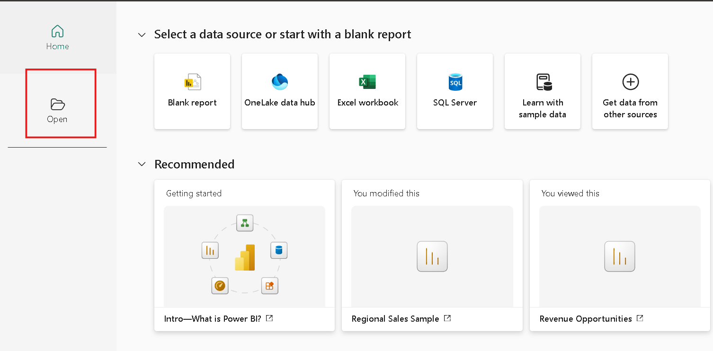
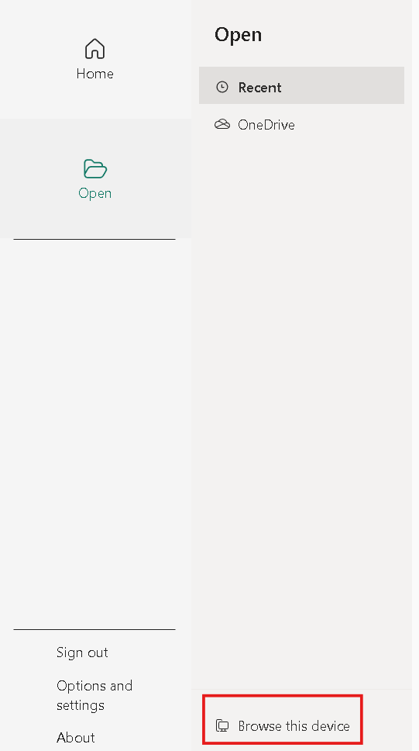
Once opened, go to the data model viewer and to ensure the data is all loaded in, you will see all the tables and their relationships, as seen in the screenshot below:
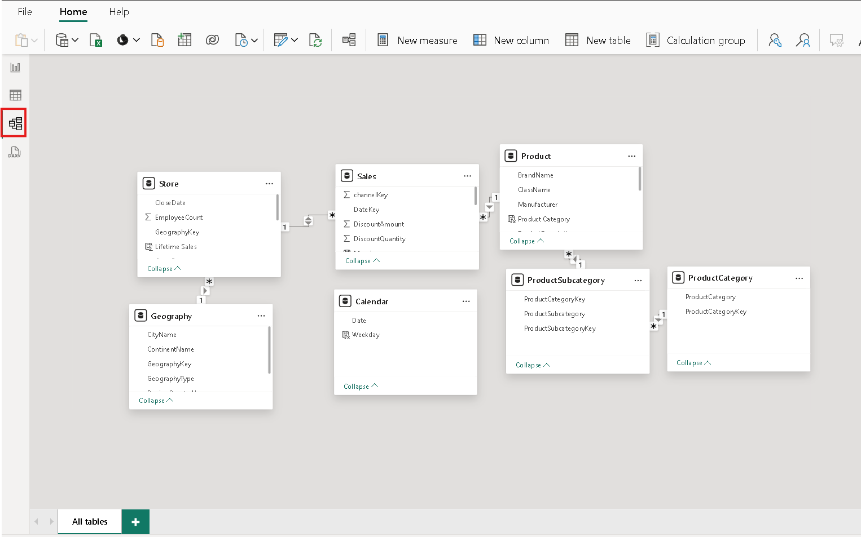

Now switch to the data view and select the Sales table under Data from the left pane.
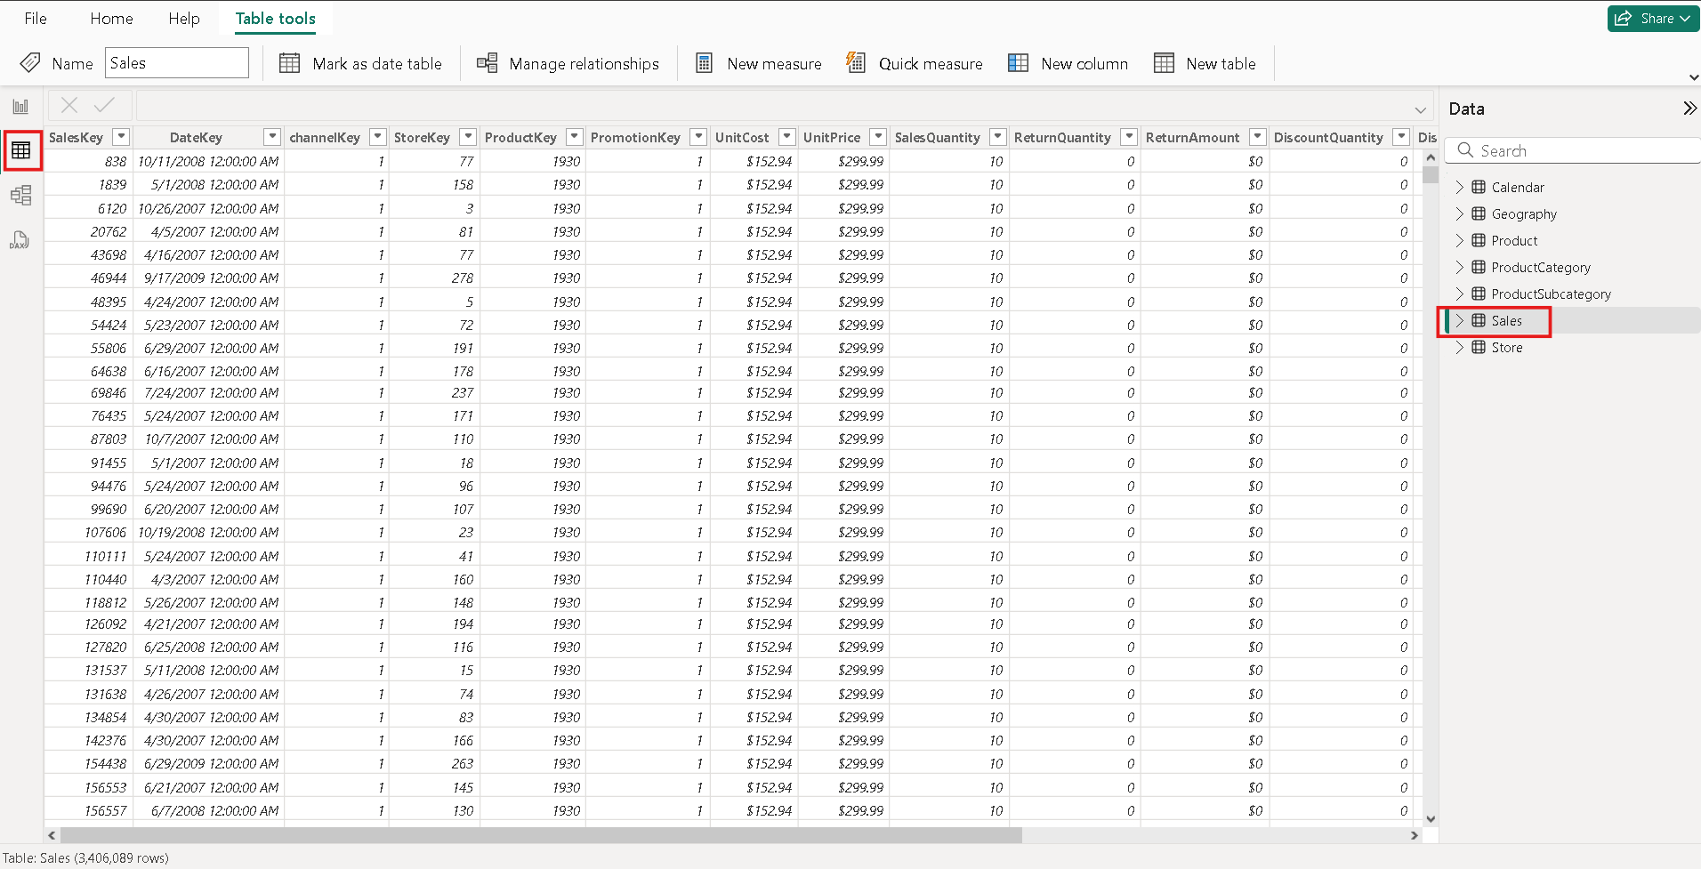
Right-click on the Sales table found on the right pane under Data, select add 'New Column.'
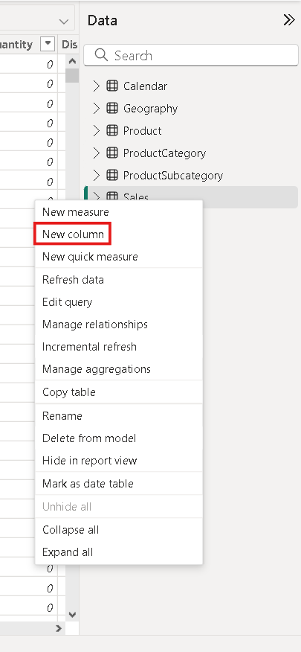
In the formula bar, type as shown below to create a calculated column and hit enter.
Margin = [SalesAmount] - [TotalCost]
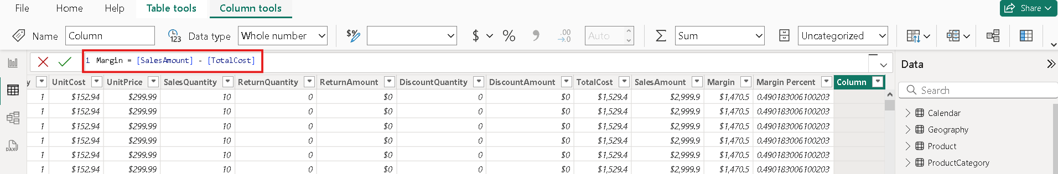
Create another column in the same way with the formula below.
Margin Percent = DIVIDE([Margin], [SalesAmount], BLANK())
STEP2: Adding Date functions in a DAX Expression
Now go to the Calendar table under the Data pane and create a new column in this table with the formula below.
Weekday = FORMAT([Date], "ddd")
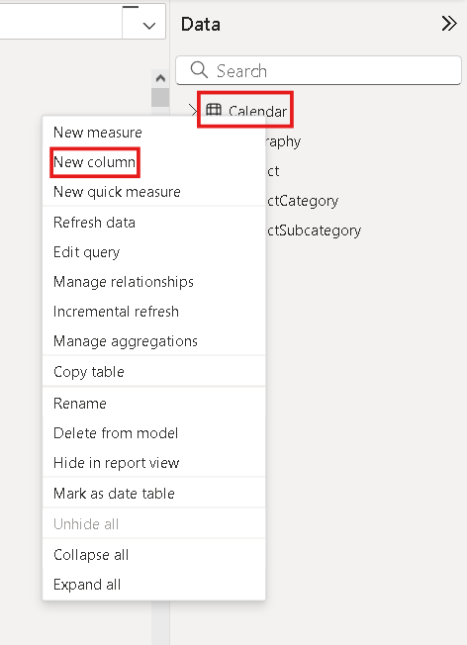
This is how we create new columns like the Weekday column.
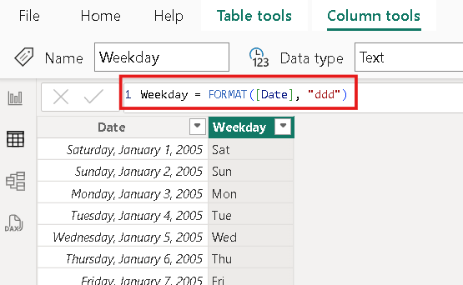
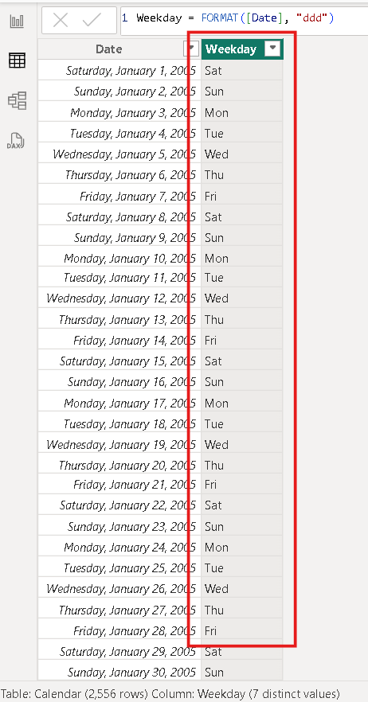
STEP3: Using Data from Related table in an Expression.
Now let us work on the Product table.
Create a new column in the Product table using the formula below.
Weight Label = IF(ISBLANK([Weight]), BLANK(), [Weight] & " " & [WeightUnitMeasureID])
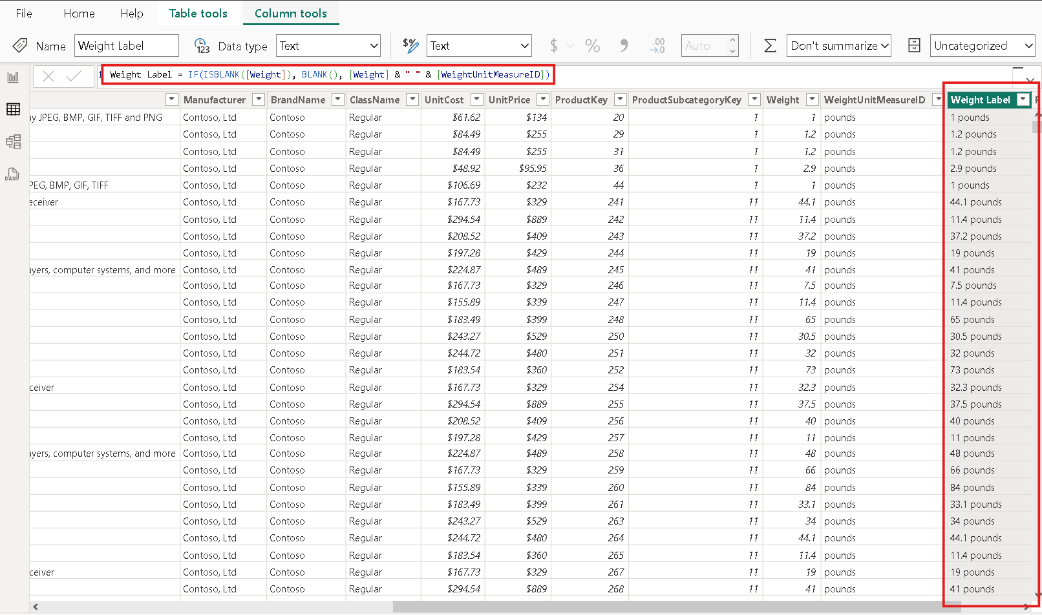
Create another column, Product Category using the Related function.
Product Category = RELATED('ProductCategory'[ProductCategory])
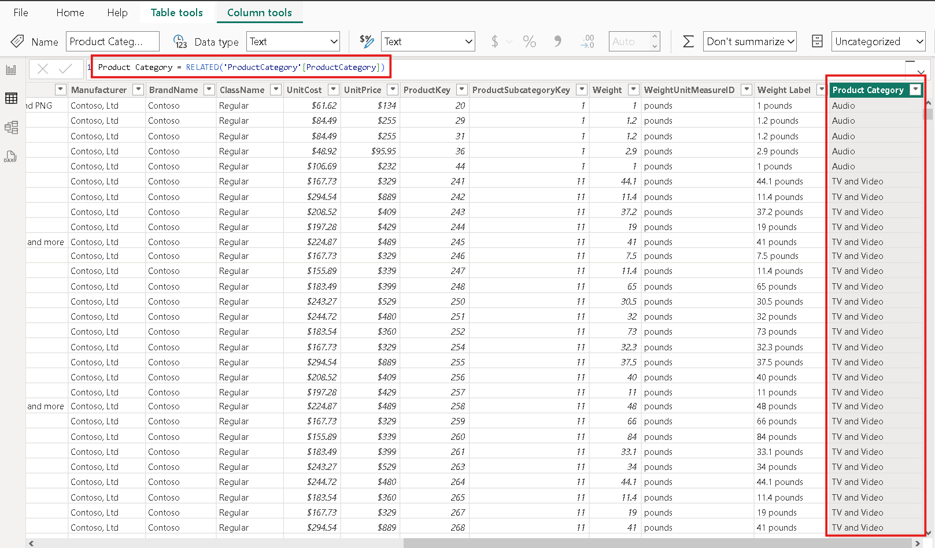
STEP 4: Implementing Conditional Logic in an Expression
Now let us work on the Store table and create a new column, Years Open, with the formula below.
Years Open = TRUNC(YEARFRAC([OpenDate],
If(ISBLANK([CloseDate]), TODAY(), [CloseDate])), 0)
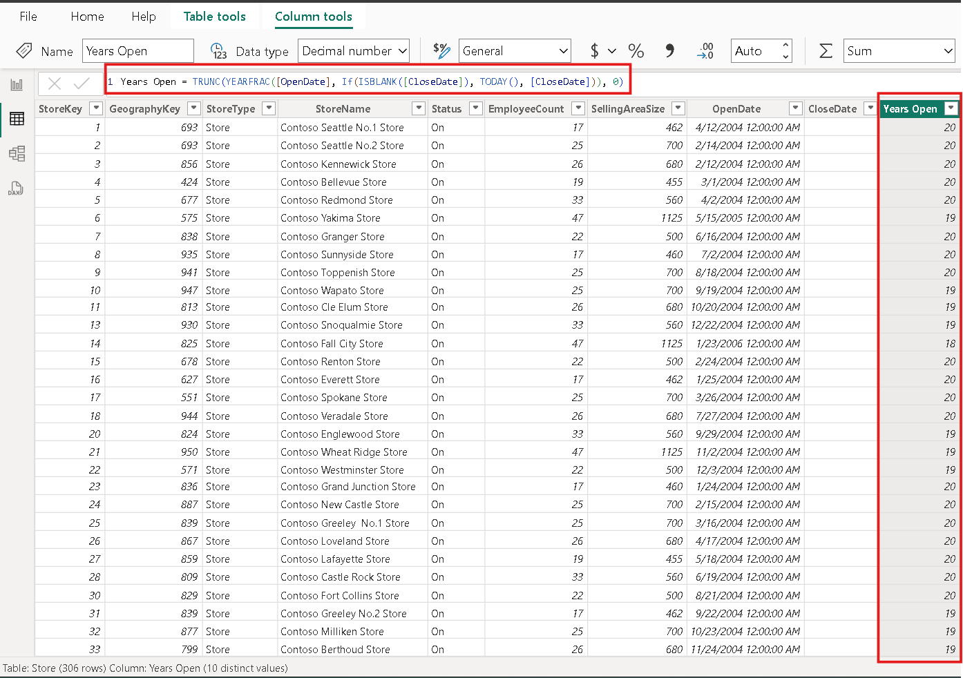
Create another column, Lifetime Sales using the following formula.
Lifetime Sales = SUMX(RELATEDTABLE(Sales), Sales[SalesAmount])
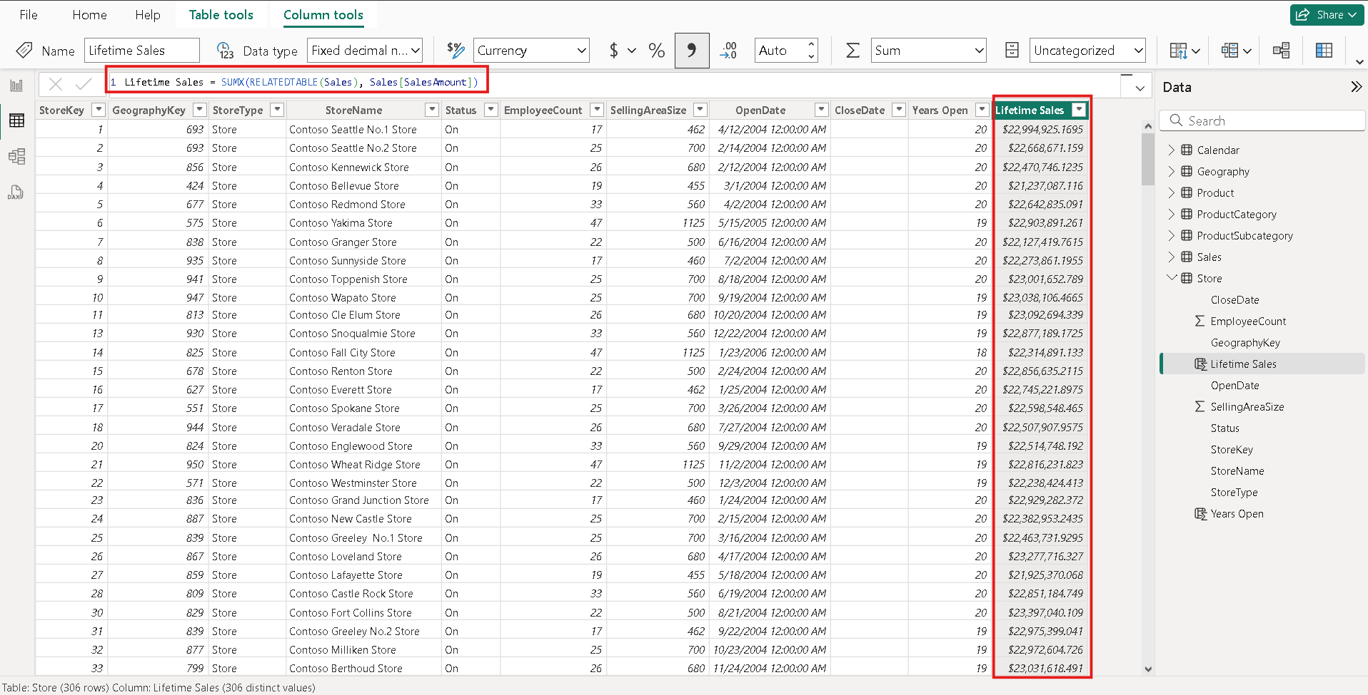
At this point, please take a screenshot of each of the tables showing all the newly added and paste them into your submission document.
Save the changes before closing Power BI.

Push your work to GitHub.

Include your screenshots stored in this file: HOS07A-2 – Name_Submission.pdf.

Follow the instructions on the CityU STC TA Center Github.io. Submit your work page.

